Fidelity Leap – Using the Coding Jam Scoreboards

Getting a Windows VM
To access a scoreboard you must use a Windows VM within the scoreboards course. Each instructor who wants to be able to access a scoreboard should register for the following course:
https://learn.neueda.com/094725
The registration code, if you are asked for it, is : PUPXVL
Once you have registered for the course, click on the Windows VM link to get access to a Windows VM. DO NOT USE THE LINUX VM links.
Within the Windows VM, wait for the browser to open on the course page. Here you’ll find the links you can click on to get to the scoreboard for your location and the scoreboard admin / config pages.

Troubleshooting
If your scoreboard is offline it probably means that the linux machine that is running your scoreboard has closed down – if that happens, go to: https://management.neueda.com/courses/CzpPzq9UK8
Login, and then click on the link for “VM Management & Engagement”. Choose Linux from the dropdown, find your machine (note the assignee) and then click on Actions + Turn on.
DO NOT create a new linux machine!

Using the scoreboards

1. The Player view  The link to the scoreboard will show you the player view - this will contain the screen that users will see, and so is suitable to be shown on a big screen. This page auto refreshes with the latest game information every few seconds (so it will look a bit odd until the game has been set up with some teams). | 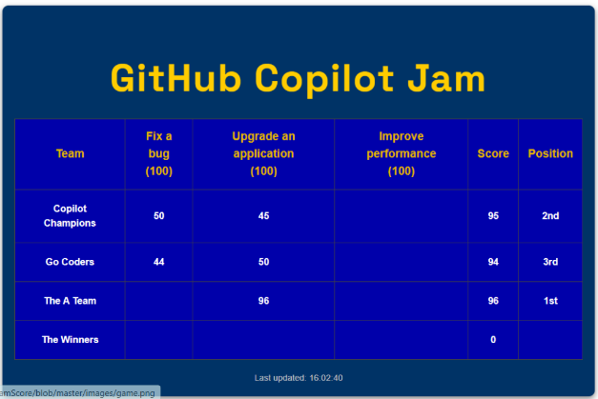
2. The Config view  On this page you can set the game name and edit the names of the list of challenges (some information is provided here by default). When you are ready click on Save, then click on Run Game.  If you want to reset the system to the default data, click on Create Brand New Game. | 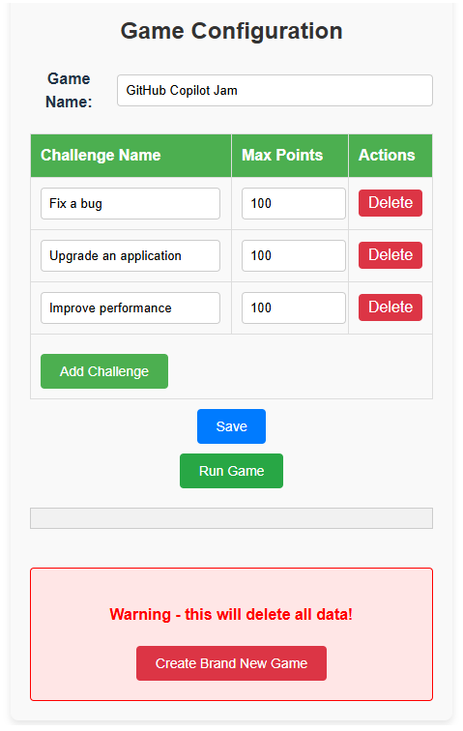
3. The Admin view  To start the game, first add the teams - you can do this on the admin page.  Click on Add team and enter a team name. Do this until you have added in all the teams.  Note that you can return to the config screen by clicking on Configure Game | 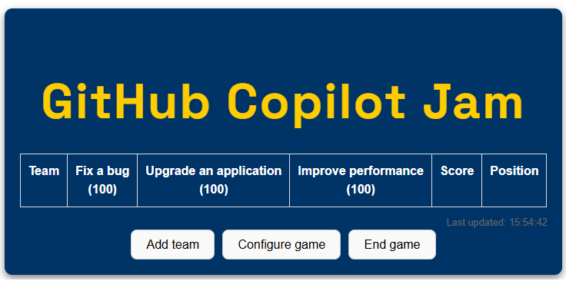
Edit teams  You can remove a team by clicking on the red X next to a team name, or edit a team name by clicking on it. | 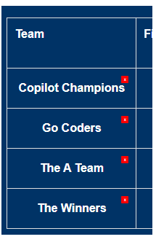
Providing scores  As each team completes a challenge, click on the relevant box to enter a score.  You can edit a score by clicking on it. Note that the maximum score is shown for info only - you can put a score in that is outside this range (or even negative!) | 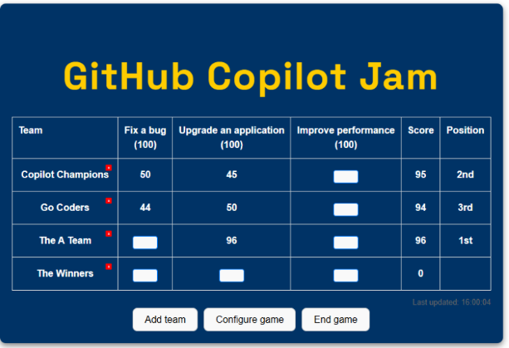

Finish the game
When the game is over click on End Game. This will make the player view show the final scores.
If you end a game too early, you can re-start the game by clicking on Configure Game and then Run Game - no data will be deleted unless you click on the Create Brand New Game button.

